# Starting HP UFT tests from IBM RQM

## Configuring the adapter

For RQM 6.0.3, the adapter for HP UFT (“Rational Quality Manager HP Quick Test Professional (QTP)/HP Unified Functional Testing (UFT) Adapter”) can (provided that you have a free Jazz.net account) be downloaded from:

<https://jazz.net/downloads/rational-quality-manager/releases/6.0.3?p=allDownloads>

Note that even though the web page above indicates that the adapter works with HP UFT up to version 12.51, the adapter will probably work with newer versions of HP UFT. We have tried it successfully with HP UFT 14.01.

### Installing the QTPAdapterWebUI on the server running IBM RQM

### The downloaded RQM-QTP-Adapter-v6.0.3.zip file contains two zip files. One of them is QTPAdapterWebUI.zip, and that zip file is the part of the adapter that should be installed on the server running IBM RQM.

1. Unzip QTPAdapterWebUI.zip in an appropriate new adapter installation directory on the server running IBM RQM. As an example, we are unzipping the zip file contents in the following directory:

C:\QTPAdapterWebUI\

1. Update the *.ini file to point out the path to the *.updatesite directory. In our example, the url line may for instance be changed to:

url=file:///C:/QTPAdapterWebUI/com.ibm.rqm.adapter.qtp.web.updatesite

1. Copy the *.ini file to to the RQM provision_profiles directory. In our example, we are copying the *.ini file to the following directory:

C:\Lars\CLM\server\conf\qm\provision_profiles\

1. With IBM RQM up and running, go to the requestReset URL in a web browser. In our example, the URL is:

<https://localhost:9443/qm/admin/cmd/requestReset>

1. Restart the IBM RQM server.

### Installing the QTPAdapterInstaller on the computer running HP UFT

### The downloaded RQM-QTP-Adapter-v6.0.3.zip file contains two zip files. One of them is QTPAdapterInstaller.zip, and that zip file is the part of the adapter that should be installed on the computer running HP UFT.

### Unzip QTPAdapterInstaller.zip in a temporary directory on the computer running HP UFT. As an example, we have unzipped the QTPAdapterInstaller.zip file contents in the following temporary directory:

C:\Temp\RqmUftAdapter\QTPAdapterInstaller\

1. One of the unzipped files is QTPAdapter.zip. Unzip QTPAdapter.zip in a new adapter installation directory on the computer running HP UFT. In our example, we have unzipped the QTPAdapter.zip file contents in the following new adapter installation directory:

C:\Lars\UFT\QTPAdapter\

1. One of the unzipped files from QTPAdapter.zip is …\bin\launchQTPAdapterConsole.bat. Add a line in the beginning of the file to point out a jre (Java run time engine) installed on the computer. In our case, we are adding the following line:

set JAVA_HOME="C:\Program Files (x86)\Java\jre6"

1. One of the unzipped files from QTPAdapter.zip is ..\bin\scriptRunner.vbs. Add two lines in the beginning of the file to indicate where HP UFT can be found. In our example, we are adding the following lines:

Dim qtpInstallHome

qtpInstallHome = "C:\Program Files (x86)\HPE\Unified Functional Testing"

### Configuring the adapter on the computer running HP UFT

1. Start the adapter console and UI by double-clicking on ..\bin\launchQTPAdapterConsole.bat. In our example, we are double-clicking on:

C:\Lars\UFT\QTPAdapter\QTPAdapter\bin\launchQTPAdapterConsole.bat

1. In our example, we have the following settings in the adapter UI (the settings are explained below the image):

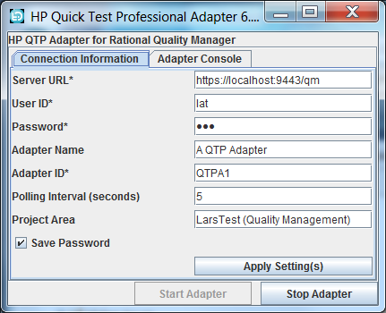

**Server URL** points out the base URL for accessing IBM RQM.

**User ID** and **Password** are related to the IBM RQM user (having a “Rational Quality Manager – Connector” client access license) that the adapter will use to access IBM RQM.

**Project Area** holds the exact name of the RQM project area that is used for storing RQM test cases with RQM test scripts that refer to HP UFT test cases.

### Once you have entered the values, press the Apply Setting(s) button, and press the Start Adapter button.

### If the adapter UI console window is adding a new row every 5 seconds with the following text “Stored configuration is out of sync. Adapter is re-registering.”, there is something wrong. It may be:

### The RQM project area is spelled wrong in the adapter UI.

### The adapter UI RQM user does not have the Rational Quality Manager – Connector client access license.

### The adapter has not been registered in IBM RQM.

## Using the adapter

### Creating a simple test in HP UFT

We can start HP UFT 14.01 from the Windows start menu, with:

All Programs > HPE Software > HPE Unified Functional Testing > HPE Unified Functional Testing

1. If the Add-in Manager dialog appears, in our case, it is enough to have the “Web” add-in selected.
2. Create a new solution.
3. Add a new test below the solution.
4. Add a call to new action below the test.

Now, we have an empty test. For our purposes, we can live with an empty test.

In the normal case, the test would test something. We would:

1. Double-click on the action.

2. Press the toolbar button “Toggle between the Keyword View and Editor” to get a view where it is easy to add a step (provided that we have loaded the Object Repository Manager with references to parts of the UI we want to operate on).

3. Add steps.

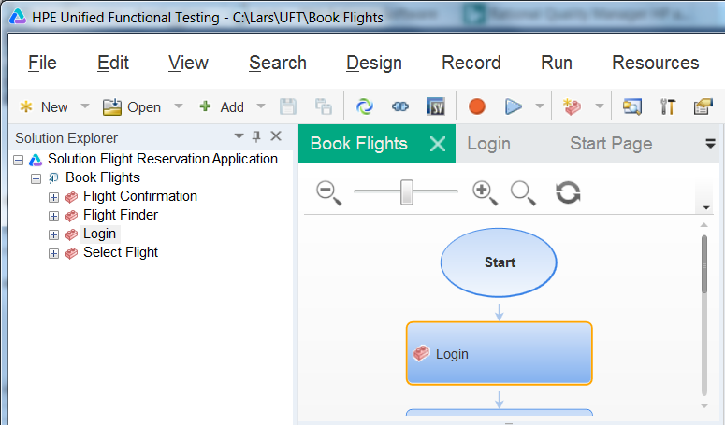

Image above: HP UFT with solution Flight Reservation Application, containing test Book Flights with several actions.

To run our test from HP UFT, we select the test, and press the Run… button in the toolbar. When we close the dialog that appears, the test will be run, and the test result will be presented. Since our test is empty, we will get a successful/passed result in the form of a checkmark in a green circle.

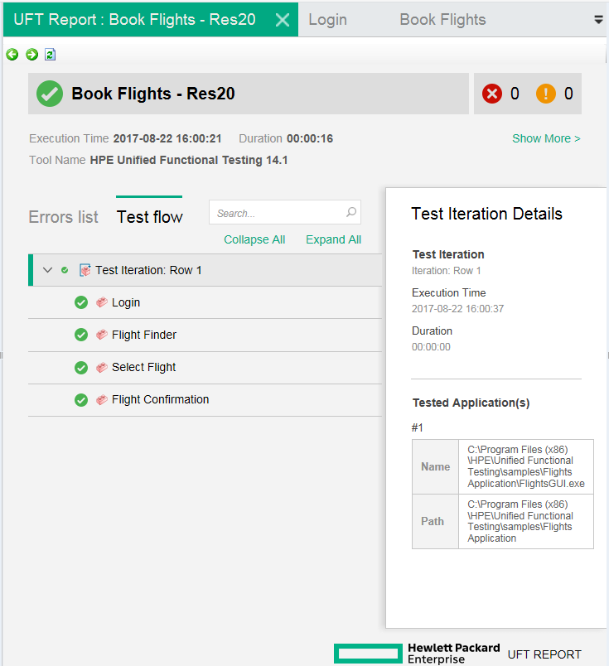

Image above: A successful test result as it is presented in HP UFT.

Now, we want to run the same test in HP UFT, but we want to start the test from RQM, and get the result reported back to RQM. Read on, to get the complete story!

### Running the HP UFT test from IBM RQM

Make sure that the IBM RQM adapter console and UI are up and running on the computer running HP UFT:

* Check that the “Start Adapt…” button in the adapter UI has been pressed.

Log in to IBM CLM and navigate to the IBM RQM project that the adapter is using (according to the adapter UI settings).

#### Create a test script

Create a test script, with Type set to “HP Quick Test Professional 11.x”. (This type is only available if the adapter has been installed on the IBM CLM/IBM RQM server.)

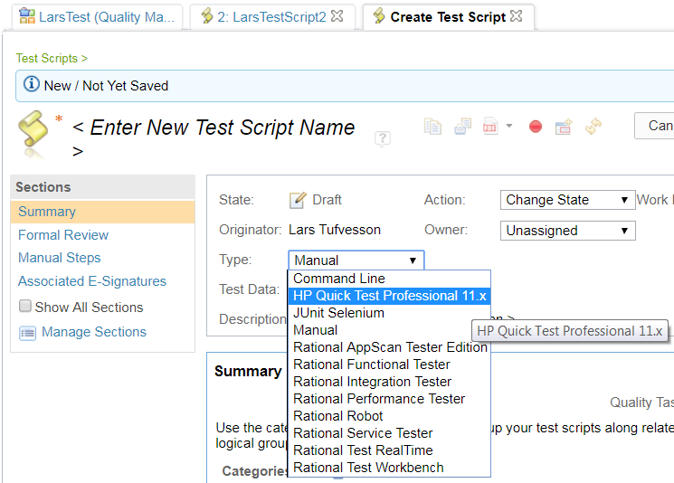

* In the QTP Script Details section that appears (see next image), select “Use test resources that are local to a test machine”.

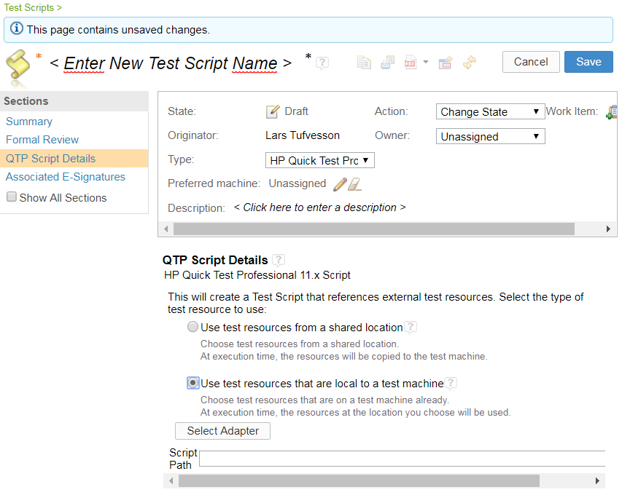

* Press the Select Adapter button that appears.
* If the adapter is up and running, with correct settings for RQM user/password and project area:
  + The first page of the wizard dialog that appears should have a list entry representing the adapter (see next image). Select the adapter and press Next.

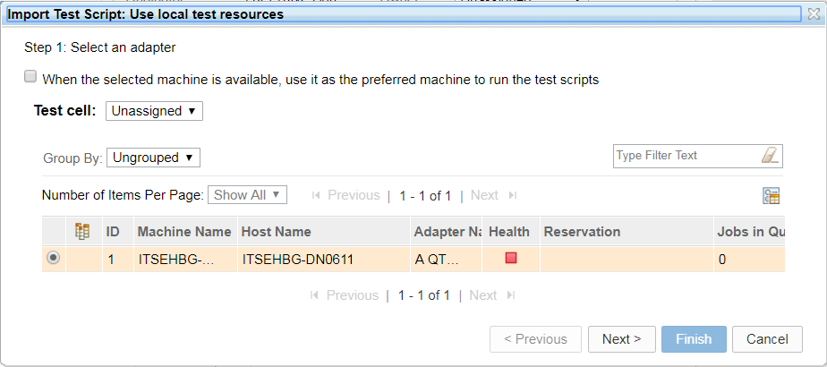

* + In the second page of the wizard dialog:
    - Specify the Project Path to the HP UFT project in the file system. (For instance: “C:\Lars\UFT”), and press the Go button (to the right of the text input field, see next image).
    - In the lower part of the dialog, select one of the tests that appear when the Go button is pressed.

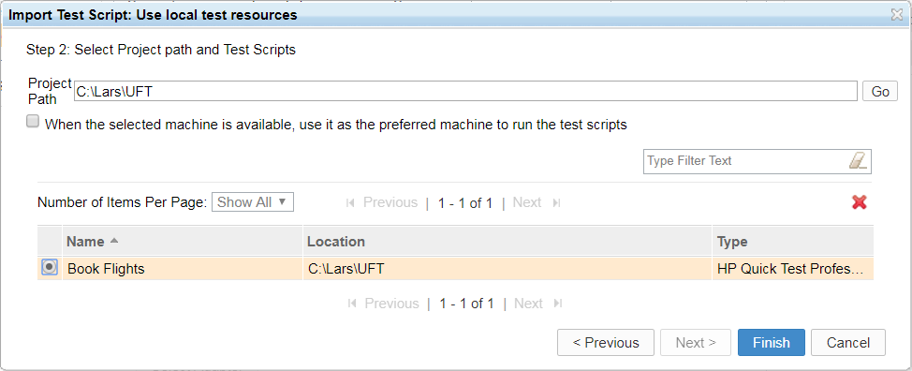

* + - Press Finish to close the dialog.
    - Press Save to save the test script.

#### Create a test case that refers to the test script

Use Construction > Create Test Case

Give the test case a name.

In the Test Scripts section for the new test case, press the green “+” button to add the test script you previously created.

Save the test case.

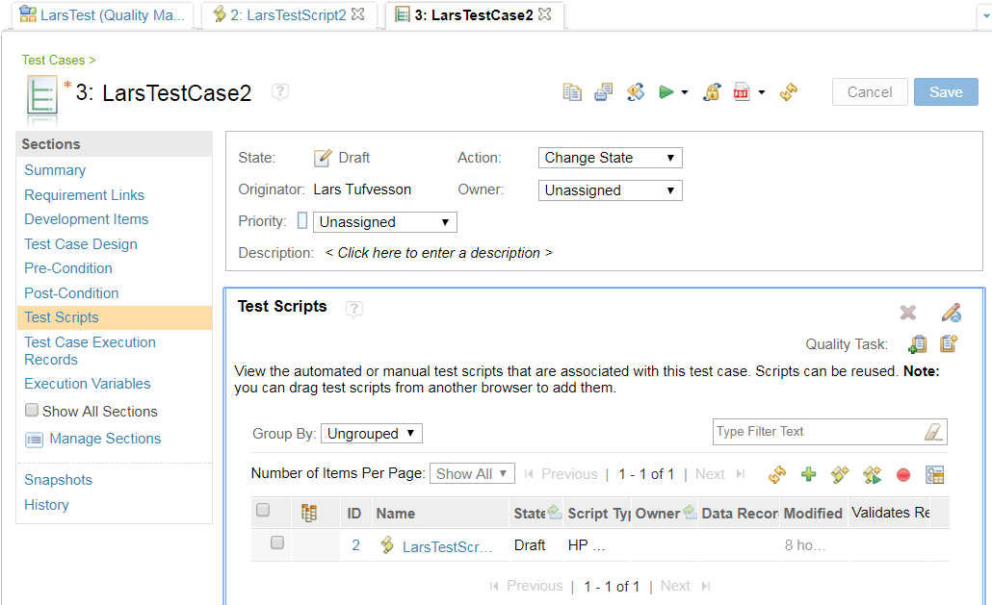

#### Create a test case execution record for the test case

In the Test Case Execution Records section for the new test case, press the Generate New Test Case Execution Records button. In the wizard dialog that appears, press Next, Next and Finish with default values.

Save the test case.

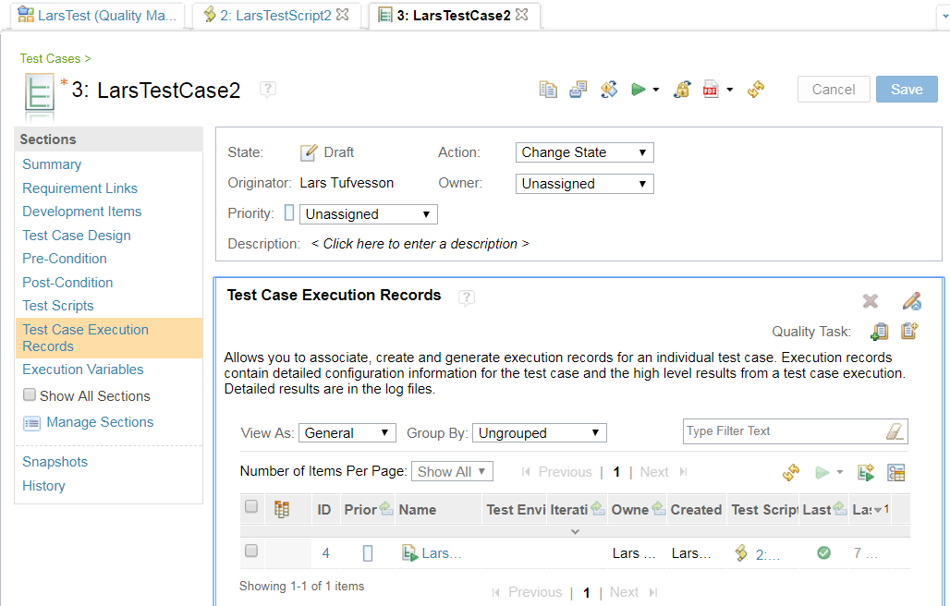

#### Run the HP UFT test from IBM RQM

To run the HP UFT test from IBM RQM, the following things must be met:

1. The IBM CLM server is up and running
2. The adapter is up and running (i.e. the adapter window should be visible and the Start Adapter button should have been pressed and there are no error messages in the adapter console window).

Note that to run the HP UFT test from IBM RQM, you do NOT need to start HP UFT first, since the adapter will start HP UFT when needed.

In IBM RQM, in the Test Case Execution Records section for the test case, select the checkbox for the test case execution record, and use the green Run Test button and the Run drop-down menu choice to start the execution of the test in HP UFT.

* HP UFT will start.
* The HP UFT test will be run, and the result will be reported back to the IBM RQM test case execution record.

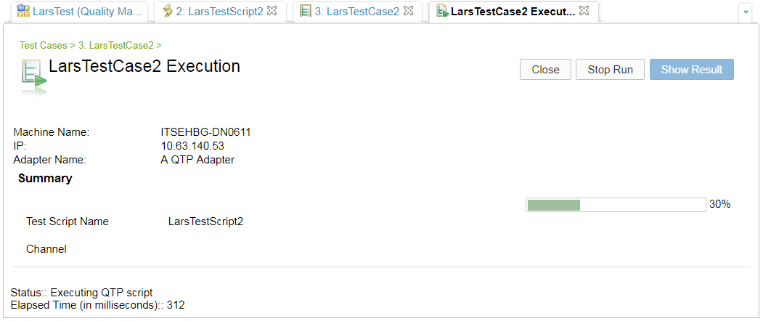

* HP UFT will finish, and the result will be reported in IBM RQM.

